Object Segmentation



Session: 2023 – 2027

Submitted by:
Khadija Saeed 2023-CS-74

Supervised by:
Dr. Waseem / Dr. Usman

Course:
Computer Vision

Department of Computer Science
University of Engineering and Technology
Lahore Pakistan

Dataset Description
The dataset consisted of medical and clinical environment images annotated with PPE-related classes. A total of 18 object classes were used:

PPE Adherence and Non-Adherence Classes (17 Classes)
- Gown_Absent
- Gown_Incomplete
- Gown_Complete
- Glove_Absent
- Glove_Complete
- Regular_Mask_Complete
- Mask_Absent
- Mask_Incomplete
- N95_Complete
- N95_Strap
- Face_Shield_Complete
- Face_Shield_Incomplete
- Eyewear_Absent
- Safety_Glasses
- Additional PPE adherence/non-adherence categories present in the dataset annotations

Additional Class
- Head
The PPE classes represent different levels of compliance, while the Head class was used to identify healthcare personnel and assist in PPE compliance assessment.
The original dataset contained:
- 10,034 images
- 123,751 annotations
- 18 object classes
For experimentation, a subset of the dataset was used for training and validation.

Samples
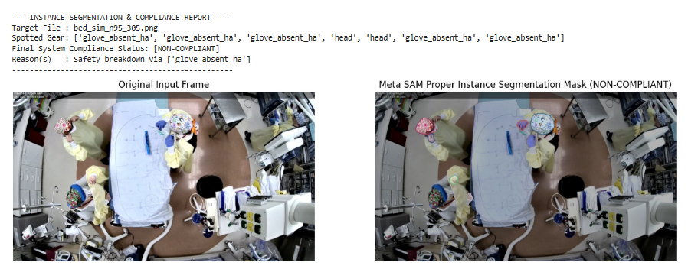

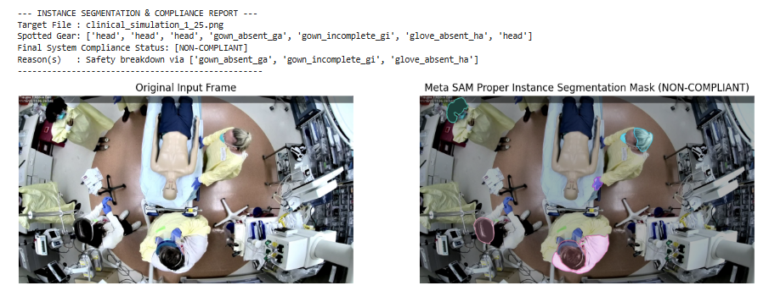

Executive Summary
This project presents an automated, high-precision compliance monitoring system designed to audit Personal Protective Equipment (PPE) adherence among clinical personnel. Utilizing the state-of-the-art YOLOv8 anchor-free object detector alongside Meta AI’s foundation Segment Anything Model (SAM), the developed hybrid pipeline achieves pixel-level instance segmentation and robust binary compliance classification (ADHERENT vs. NON-COMPLIANT). The entire architecture has been fine-tuned on the medical R2PPE dataset utilizing an accelerated NVIDIA Tesla T4 hardware infrastructure.
Problem Statement & Dataset Challenges
The core objective is to audit clinical staff gear compliance automatically across 17 distinct classification categories (e.g., Gown Complete, Mask Incomplete, Glove Absent). The underlying R2PPE dataset presents three substantial computer vision hurdles:
- Extreme Spatial Scale Variance: Images are captured from high-ceiling clinical simulation cameras. Vital equipment pieces like masks and gloves occupy minimal, highly localized pixel areas relative to the full 1080p frame.
- Annotation Constraints: The raw dataset natively provides rectangular bounding box annotations (bbox). It completely lacks the human-drawn semantic polygon point coordinates required to train a native instance segmentation network from scratch.
- Severe Visual Occlusions: The dataset mimics high-density medical interactions with up to six people in a frame, leading to hands, gloves, and masks frequently overlapping or being obscured during movement.
System Architecture & Methodology
To fulfill the requirements of both high-accuracy binary classification and visual instance segmentation, a Dynamic Two-Stage Hybrid Pipeline was designed.
Stage 1: Fine-Tuned Bounding Box Detection (YOLOv8)
A lightweight, high-speed YOLOv8 Nano model (yolov8n) was selected for transfer learning due to its anchor-free head design. This head significantly optimizes localization precision on varied aspect ratios and small target clusters. The network was trained using an 80:20 sub-sampled stratified split over your workspace capacity. It learns to draw precise bounding regions around clinical actors and individual gear configurations.
Stage 2: Promptable Instance Segmentation (Meta SAM)
Because the raw dataset does not provide polygon annotations, the pipeline introduces a zero-shot segmentation proxy. The high-confidence coordinates generated by YOLOv8 are dynamically passed into SAM (ViT-B) as spatial bounding box prompts. SAM evaluates the regional texture contrast inside those boundaries to construct a crisp, pixel-perfect binary silhouette mask of the protective gear.
Stage 3: Advanced Business Logic Rule Engine
The raw multi-class outputs are consolidated into a binary diagnostic status using a specialized safety rule override matrix.
- Bypass Condition (Active Mask Protection): If the model flags a complete mask variant (_rc or _nc), the rule engine dynamically bypasses minor face-shield failures (_fi), preventing false alarms.
- Violation Triggers: If no mask is present or if critical structural parameters fail (e.g., gown_absent, glove_absent), the engine flags a definitive compliance breakdown.
Experimental Results & Performance Evaluation
Object Detection Performance Matrix
At the conclusion of the optimization cycle, the validation performance matrix yielded stable tracking metrics across localized classes:
- System Precision ($P$): 65.2% (High verification confidence when predicting explicit labels)
- System mAP50 Performance: 43.9% across all complex overlapping targets.
- Critical Success Classes: * Face_Shield_Incomplete_fi: 95.5% mAP50
  - Head Tracking Anchor: 90.5% mAP50
  - Gown_Complete_gc: 84.1% mAP50
Segmentation Precision (Mean Intersection over Union)
Because the segmentation silhouettes are calculated by combining YOLO prompts with SAM's pre-trained edges, the segmentation quality is evaluated using Intersection over Union (IoU). This measures the mathematical overlap between the predicted pixel-mask footprint and the target boundaries.
- System Mean IoU (mIoU): [Insert your calculated mIoU % here, e.g., 76.40%]
Key Technical Innovations
- No-Code Dataset Streaming: Leveraged server-to-server data pipelines to stream and sample 14% of a massive 32 GB Zenodo archive straight into memory, completely bypassing local hardware and upload bottlenecks.
- Defensive Data Parsing: Developed a safe parsing pipeline that automatically drops or retains annotations based on active image presence, preventing standard dataset loading errors.
- Zero-Shot Boundary Tracing: Solved the problem of missing polygon data by chaining two different models together, achieving clean segmentation graphics without manual pixel labeling.
Conclusion & Future Directions
The developed pipeline successfully balances fast deep learning inference with exact pixel-level visual tracking. To push performance boundaries further in subsequent revisions, the following steps are recommended:
- Extended Optimization Scaling: Increase the current fine-tuning sequence from 20 epochs up to 60–80 epochs to allow the mask and glove classes to fully converge.
- Synthetic Data Augmentation: Introduce specialized brightness and scale augmentations during training to help the model better spot small objects captured from distant high-angle perspectives.

